# Partnership Agreement

**This Brand Partnership Agreement** ("Agreement") is made and entered into as of {{start_date}}, between:

**SuperBuzz Marketing Technologies Private Limited** ("Cherry"), with its principal place of business at Site No 26, VO-357, Wework Prestige Cube Parking, 5th Block, Laskar, Hosur Road, Koramangala, Bengaluru, Karnataka, 560095, and

**{{company_name}} (**“{{brand_name}}”) with its principal place of business at {{company_address}}

**RECITALS:**

WHEREAS, Cherry operates a platform that incentivises users to purchase products from partnered brands and post about them on social media in exchange for discounts and/or cashback.

WHEREAS, {{brand_name}} is a company specialising in {{industry}} and desires to partner with Cherry to increase brand visibility and drive sales.

NOW, THEREFORE, in consideration of the mutual covenants and agreements contained herein, the parties agree as follows.

## **1. Scope of Partnership**

1.1 **Cashback Incentive:** Cherry will offer cashback to users who purchase {{brand_name}} products and post about their purchase on social media. The amount of cashback offered will be determined by Cherry’s user cashback algorithm. Cherry does not take any cut from the cashback provided to users.

1.2 **Commission per Post:** {{brand_name}} agrees to pay Cherry a fixed commission for each social media post made via Cherry, by users tagging {{brand_name}} on Instagram. This commission is in addition to the cashback provided to users. This rate is Rs. {{flat_fee}} per post.

1.3 **Deposit Payment:** {{brand_name}} agrees to pay a one-time deposit of INR {{deposit}} (Rupees {{deposit_in_words}}) to Cherry.

1.4 **Cashback Disbursement:** Cherry will be responsible for disbursing the cashback directly to the users who qualify under the cashback program.

1.5 **Invoicing:** At the end of each month, Cherry will invoice {{brand_name}} for the total amount of cashback disbursed to users, the commission per post as outlined in Section 1.2, and the listing fee if applicable.

## **2. Payment Terms**

2.1 **Listing Fee Payment:** {{brand_name}} agrees to pay the one-time deposit of INR {{deposit}} before the commencement of this agreement. This will be used as a deposit for cashback to Cherry users.

2.2 **Cashback and Commission Reimbursement:** {{brand_name}} shall reimburse Cherry for the total amount of cashback disbursed to users and the commission per post as detailed in the monthly invoice provided by Cherry. Payment shall be made within 15 days of receipt of the invoice.

## **3. Reporting**

3.1 **Monthly Reporting:** Cherry will provide {{brand_name}} with a monthly report detailing the users who received cashback for purchasing products and posting about them on social media, the number of posts, and the total amounts invoiced.

## **4. Term and Termination**

4.1 **Term:** This Agreement shall commence on {{start_date}} and shall continue until terminated by either party with 30 days written notice.

4.2 **Termination for Breach:** Either party may terminate this Agreement immediately if the other party breaches any material terms and fails to remedy the breach within 15 days of receiving notice.

## **5. Confidentiality**

5.1 **Confidential Information:** Both parties agree to maintain the confidentiality of any proprietary or confidential information shared during the course of this partnership.

## **6. Miscellaneous**

6.1 **Governing Law:** This Agreement shall be governed by and construed in accordance with the laws of India.

6.2 **Entire Agreement:** This Agreement represents the entire understanding between the parties and supersedes all prior agreements related to the subject matter.

6.3 **Amendments:** Any amendments or modifications to this Agreement must be in writing and signed by both parties.

IN WITNESS WHEREOF, the parties have executed this Agreement as of the date first above written.

**SuperBuzz Marketing Technologies Private Limited.**

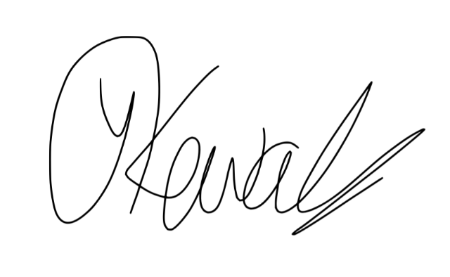

Name: Yash Kewalramani

Date: {{start_date}}

**{{company_name}}**

Name: ___________________________

Title: ___________________________

Date: ___________________________